**Program: 1**

**package** Practice2;

**import** java.util.Scanner;

**public** **class** Matrix1 {

**public** **static** **void** main(String args[]){

**int** i,j,k;

**int** arr[][] = **new** **int**[3][3];

**int** arr1[][]=**new** **int**[3][3];

**int** arrt[][] = **new** **int**[3][3];

**int** arrm[][]=**new** **int**[3][3];

Scanner scan = **new** Scanner(System.***in***);

System.***out***.print("Enter 3*3 Array1 Elements : ");

**for**(i=0; i<3; i++)

{

**for**(j=0; j<3; j++)

{

arr[i][j] = scan.nextInt();

}

}

System.***out***.print("Enter 3*3 Array2 Elements : ");

**for**(i=0; i<3; i++)

{

**for**(j=0; j<3; j++)

{

arr1[i][j] = scan.nextInt();

}

}

**for**(i=0; i<3; i++)

{

**for**(j=0; j<3; j++)

{

arrt[i][j] = arr[j][i];

}

}

System.***out***.print("Transpose of the first Matrix is :\n");

**for**(i=0; i<3; i++)

{

**for**(j=0; j<3; j++)

{

System.***out***.print(arrt[i][j]+ " ");

}

System.***out***.println();

}

System.***out***.println("Two marix multiplication is");

**for** (i = 0; i < 3; i++) {

**for** (j = 0; j < 3; j++) {

**for** (k = 0; k < 3; k++) {

arrm[i][j] += arr[i][k] * arr1[k][j];

}

}

}

**for** (i = 0; i < 3; i++) {

**for** (j = 0; j < 3; j++) {

System.***out***.print(arrm[i][j] + " ");

}

System.***out***.print("\n");

}

}

}

**Output:**

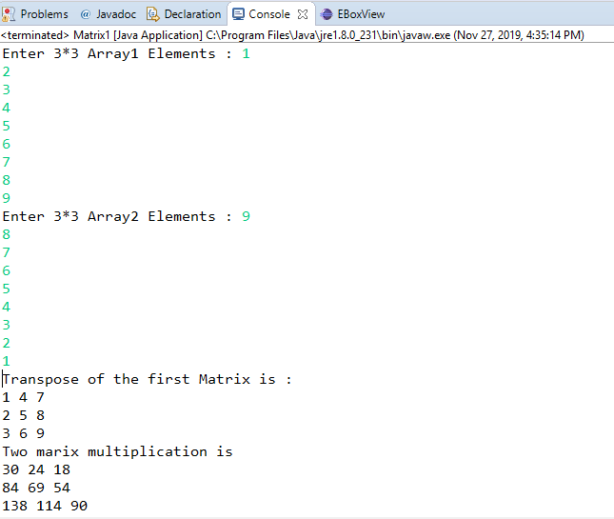

**Program: 3**

**import** java.util.Scanner;

**public** **class** Program3 {

**public** **static** **void** main(String[] args) {

                Scanner sc= **new** Scanner(System.***in***);

                System.***out***.println("Enter Name:");

                String name= sc.next();

                System.***out***.println("Enter Gender:");

                String gen= sc.next();

**if**(gen.equals("male"))

     {

     System.***out***.println("Enter age:");

**int** age= sc.nextInt();

**if**(age<20)

     {

          System.***out***.println("Not Eligible ");

     }

**else** **if**(age>=20 &&age<=30)

{

     System.***out***.println("Enter weight of the candidate(in pounds or kgs)");

**float** wt= sc.nextFloat();

**if**(wt>100)

     {

           wt = (**float**) (wt/2.2);

     }

**if**(70.4545 <= wt && wt<=79.5454)

     {

     System.***out***.println("Enter height of candidate(in inches or cms)");

**float** ht= sc.nextFloat();

**if**(ht<10)

           {

                ht = ht*2.54f;

           }

**if**(13.207<=ht && ht<=13.969)

           {

                System.***out***.println("Name   : "+name);

                System.***out***.println("Gender : "+gen);

                System.***out***.println("Weight : "+wt+" (in kgs)");

                System.***out***.println("Height : "+ht+" (in cms)");

                System.***out***.println(name+" is eligible");

           }**else**

           {

          System.***out***.println("Not Eligible");

           } }

**else**

           {

           System.***out***.println("Not Eligible");

           } }

**else** **if**(age>30 && age<=40)

     {

     System.***out***.println("Enter weight of the candidate(in pounds or kgs)");

**float** wt= sc.nextFloat();

**if**(wt>100)

     {

     wt = (**float**) (wt/2.2);

     }

**if**(77.2727 <= wt && wt<=81.8181)

     {

     System.***out***.println("Enter height of candidate(in inches or cms)");

**float** ht= sc.nextFloat();

**if**(ht<10)

     {

     ht = ht*2.54f;

     }

**if**(13.716<=ht && ht<=14.224)

     {

           System.***out***.println("Name   : "+name);

           System.***out***.println("Gender : "+gen);

           System.***out***.println("Weight : "+wt);

           System.***out***.println("Height : "+ht);

           System.***out***.println(name+" is eligible");

     }**else**

     {

           System.***out***.println("Not Eligible");

     } }

**else**

     {

     System.***out***.println("Not Eligible");

     } }

**else** **if**(40<age && age<=50)

{

     System.***out***.println("Enter weight of the candidate(in pounds or kgs)");

**float** wt= sc.nextFloat();

**if**(wt>100)

     {

           wt = (**float**) (wt/2.2);

     }

**if**(79.5454 <= wt && wt<=84.0909)

     {

     System.***out***.println("Enter height of candidate(in inches or cms)");

**float** ht= sc.nextFloat();

**if**(ht<10)

     {

           ht = ht*2.54f;

     }

**if**(14.224<=ht && ht<=15.24)

     {

           System.***out***.println("Name   : "+name);

           System.***out***.println("Gender : "+gen);

           System.***out***.println("Weight : "+wt);

           System.***out***.println("Height : "+ht);

           System.***out***.println(name+" is eligible");

     }**else**

     {

           System.***out***.println("Not Eligible");

     }

}

**else**

     {

           System.***out***.println("Not Eligible");

     }

 }

**else**

     {

           System.***out***.println("Not Eligible");

     }

}

**else**

     {

           System.***out***.println("Only male candidates are allowed");

     }

}

}

**Output:**

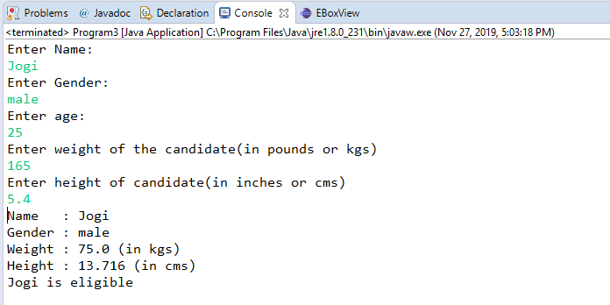

**Program: 4**

**package** Practice2;

**import** java.util.Scanner;

**public** **class** Main

{

**public** **static** **void** main(String[] args)

{

**int** n, p, x;

Scanner s = **new** Scanner(System.***in***);

n =5;

**int** a[] = **new** **int**[n+1];

System.***out***.print("Input array elements: ");

**for**(**int** i = 0; i < n; i++)

{

a[i] = s.nextInt();

}

System.***out***.print("Input the position to insert: ");

p = s.nextInt();

x = 50;

**for**(**int** i = (n-1); i >= (p-1); i--)

{

a[i+1] = a[i];

}

a[p-1] = x;

System.***out***.print("Array after insertion: ");

**for**(**int** i = 0; i < 3; i++)

{

System.***out***.print(""+a[i]+" ");

}

}

}

**Output:**

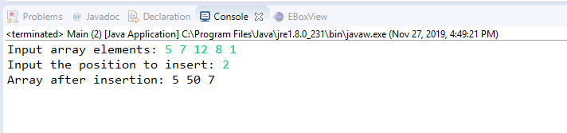

**Program: 5**

**package** Practice2;

**import** java.util.Scanner;

**public** **class** Program5 {

**public** **static** **void** main(String[] args) {

**long** acct_no;

String customer_name, trans_type;

**double** trans_amount, bal_amount,n_balance;

Scanner sc = **new** Scanner(System.***in***);

System.***out***.print("Enter Account Number:");

acct_no = sc.nextLong();

System.***out***.print("Enter Customer Name:");

customer_name = sc.next();

System.***out***.print("Enter Transtion Type:");

trans_type = sc.next();

System.***out***.print("Enter Transtion Amount:");

trans_amount = sc.nextLong();

System.***out***.print("Enter Balance:");

bal_amount = sc.nextDouble();

System.***out***.print("Enter NewBalance:");

n_balance = sc.nextDouble();

Bank b = **new** Bank(acct_no, customer_name, trans_type, trans_amount, bal_amount, n_balance);

b.transaction();

}}

**class** Bank {

**private** **long** acct_no;

**private** String customer_name, trans_type;

**private** **double** trans_amount, bal_amount,n_balance;

**public** Bank(**long** acct_no, String customer_name, String trans_type, **double** trans_amount, **double** bal_amount, **double** n_balance) { **super**();

**this**.acct_no = acct_no;

**this**.customer_name = customer_name;

**this**.trans_type = trans_type;

**this**.trans_amount = trans_amount;

**this**.bal_amount = bal_amount;

**this**.n_balance = n_balance;

}

**public** **void** transaction()

{

**double** amount = 0;

**if** (trans_type.equals("withdrawal")) {

**if** (trans_amount <= bal_amount) {

amount = bal_amount - trans_amount;

} **else** {

System.***out***.println("invaid transaction");

}

}

**if** (trans_type.equals("deposit")) {

amount = bal_amount + trans_amount;

}

System.***out***.println("Account Number :" + acct_no);

System.***out***.println("Customer Name :" + customer_name);

System.***out***.println("Transtion Type :" + trans_type);

System.***out***.println("Transaction Amount :Rs." + trans_amount);

System.***out***.println("Balance Amount:Rs."+ bal_amount);

System.***out***.println("New Balance :Rs." + n_balance);

}

}

**Output:**

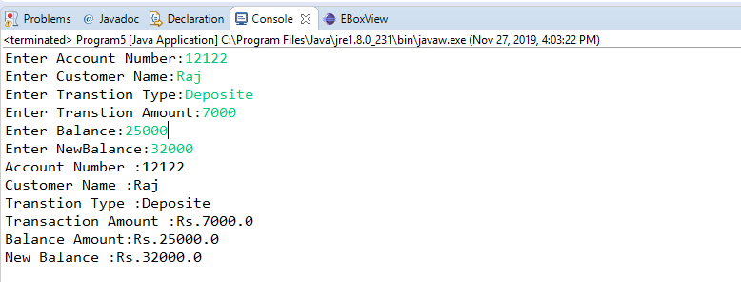

**Program: 6**

**package** Practice2;

**import** java.util.Scanner;

**public** **class** Program6 {

**private** **static** Scanner *sc*;

**public** **static** **void** main(String[] args)

{

String name;

**int** Units;

**double** BillAmount;

*sc* = **new** Scanner(System.***in***);

System.***out***.print("Customer name: ");

name=*sc*.next();

System.***out***.print("Please Enter the Units that you Consumed : ");

Units = *sc*.nextInt();

BillAmount = *Electricity*(Units);

System.***out***.println("Bill amount: = " + BillAmount);

}

**public** **static** **double** Electricity(**int** Units)

{

**double** Amount, Sur_Charge, BillAmount;

**if** (Units <=50)

{

Amount = Units * 0.50;

Sur_Charge = Amount*0.2;

}

**else** **if** (Units <= 150)

{

Amount = Units * 0.75;

Sur_Charge = Amount*0.2;

}

**else** **if** (Units <= 250)

{

Amount = Units * 1.20;

Sur_Charge = Amount*0.2;

}

**else**

{

Amount = Units * 1.50;

Sur_Charge = Amount*0.2;

}

BillAmount = Amount + Sur_Charge;

**return** BillAmount;

}

}

**Output:**

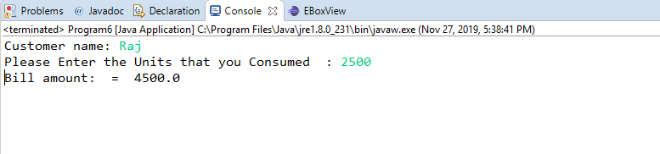

**Program: 7**

**package** Practice2;

**class** OverloadDemo {

**void** area(**double** b,**double** h)

{

System.***out***.println("Using overloaded method:");

**double** t=0.5*b*h;

System.***out***.println("Area of the Triangle : "+t);

}

**void** area(**float** a, **float** b)

{

**float** r=a*b;

System.***out***.println("Area of the Rectangle : "+r);

}

**void** area(**double** p)

{

**double** s=Math.*pow*(p, 2);

System.***out***.println("Area of the Square : "+s);

}}

**public** **class** Overload

{

**public** **static** **void** main(String args[])

{

OverloadDemo od=**new** OverloadDemo();

od.area(9.42,5);

od.area(9.0f,2.4f);

od.area(5.88);

}}

**Output:**

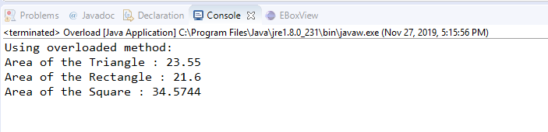

**Program: 8**

**public** **class** Person {

**private** String name;

**public** **static** **void** main(String str[]){

Person p=**new** Person ();

p.name=("\"Prateek\"");

System.***out***.print(p.name);

}}

**Output:**

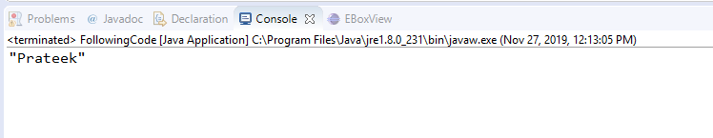

**Program: 9**

**public** **class** Test {

**public** **static** **int** m1(**int** x) {**return** ++x;}

**public** **static** **void** main (String[] args) {

**int** x = 1;

**int** y = *m1*(x);

System.***out***.println("x=" + x + ", y=" + y);

}

}

**Output:**

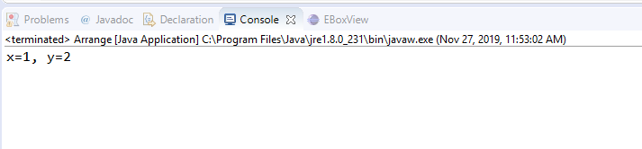

**Program: 10**

**package** Practice2;

**import** java.util.*;

**public** **class** Sample {

**public** **static** **void** main(String[] args) {

Student r=**new** Student();

r.add();

}

}

**class** Student

{

**private** **int** reg_no;

**private** String name;

**private** **double** mark;

**public** Student(**int** reg_no, String name, **double** mark) {

**super**();

**this**.reg_no = reg_no;

**this**.name = name;

**this**.mark = mark;

}

Student(){}

**public** **void** add()

{

System.***out***.print("Enter number of students: ");

Scanner sc=**new** Scanner(System.***in***);

**int** reg_no;

String name;

**double** mark;

**int** num=sc.nextInt();

Student[] stu=**new** Student[num];

**for**(**int** i=0;i<num;i++)

{

System.***out***.print("Enter registration number: ");

reg_no=sc.nextInt();

System.***out***.print("Enter student name: ");

name=sc.next();

System.***out***.print("Enter mark: ");

mark=sc.nextDouble();

Student s= **new** Student(reg_no,name,mark);

stu[i]=s;

}

**for**(Student st:stu){

System.***out***.println(st.toString());

}

}

@Override

**public** String toString() {

**return** "Student info [reg_no=" + reg_no + ", name=" + name + ", mark=" + mark + "]";

}

}

**Output:**

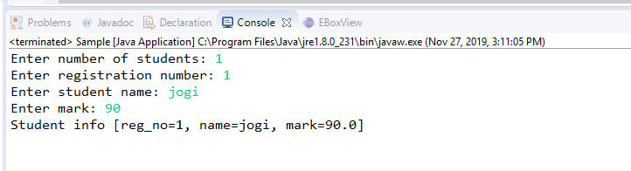

**Program: 11**

**public** **class** Point {

**public** **int** x;

**public** **int** y;

Point(**int** xcoord, **int** ycoord){

**this**.x = xcoord;

**this**.y = ycoord;

}

**public** **int** getX() {

**return** x;

}

**public** **int** getY() {

**return** y;

}

**public** **static** **int** distance(Point p1, Point p2) {

**int** sx = p1.x - p2.x;

**int** sy = p1.y - p2.y;

**return** (**int**) Math.*sqrt*(sx * sx + sy * sy);

}

**public** **static** **void** main (String str[]){

**int** x = 0;

**int** y = 0;

Point p1 = **new** Point(-1,1);

Point p2 = **new** Point(3,4);

Point mp = **new** Point(x,y);

x = (p1.getX() + p2.getX()) / 2;

y = (p1.getY() + p2.getY()) / 2;

System.***out***.print(""+Point.*distance*(p1, p2));

}

}

**Output:**

